**Java Programming**

**CSE 1007**

Lab Assignment 1

**Arrays and Loops**

Submitted by

**Om Ashish Mishra**

**16BCE0789**

**Question 1**

Write a Java program to display all the prime numbers within a range.

**Code**

import java.util.*;

class Question1

{

public static void main(String args[])

{

Scanner sc = new Scanner(System.in);

int a, b, c;

int i, j;

System.out.println("Enter the range");

a=sc.nextInt();

b=sc.nextInt();

for(i=a;i<=b;i++)

{

c=0;

for(j=2;j<i/2;j++)

{

if(i%j==0)

{

c=1;

break;

}

}

if(c==0)

{

System.out.print(i+" ");

}

}

}

}

**Output**

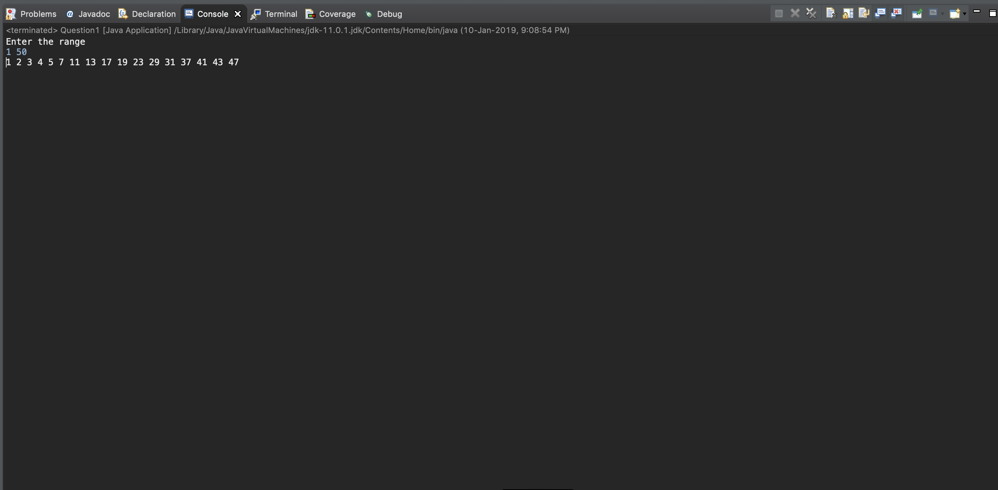

**Question 2**

Write a Java program to convert a decimal number to its equivalent binary number.   
Eg: 2510 = 110012

**Code**

import java.util.*;

public class Question2

{

public static void main(String args[])

{

//Program to convert a decimal number into its equivalent binary number

Scanner sc = new Scanner(System.in);

int num;

System.out.println("Enter a number");

num = sc.nextInt();

String bin="";

int rem, temp=num;

while(temp>0)

{

rem = temp%2;

bin = Integer.toString(rem)+bin;

temp/=2;

}

System.out.println("The binary of "+num+" is "+bin);

}

}

**Output**

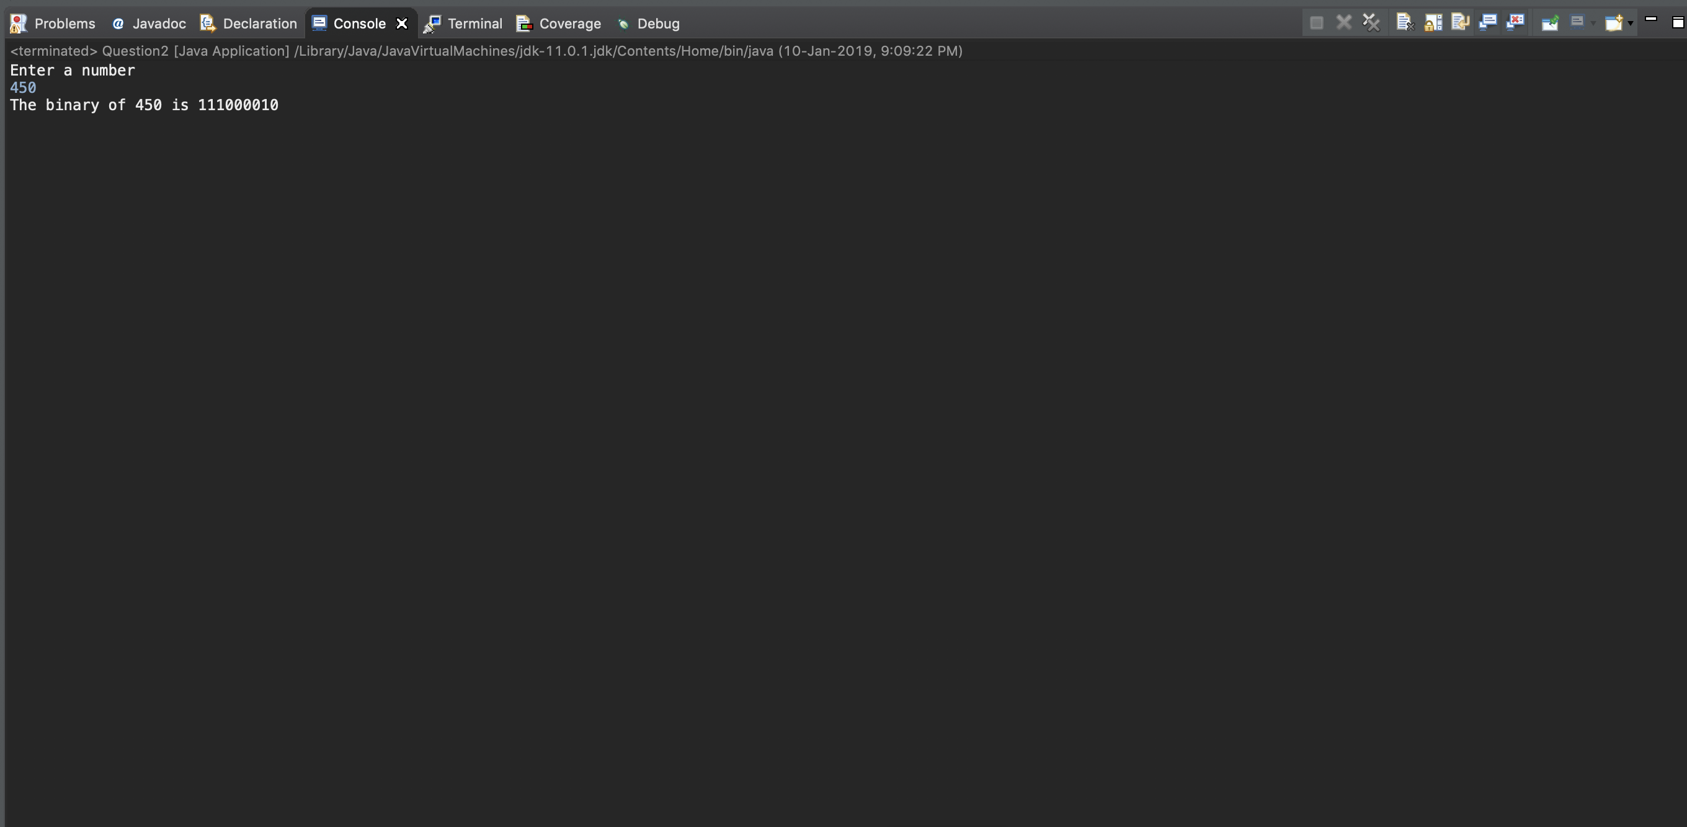

**Question 3**

Write a Java program to print the following patterns by reading the number of lines   
from the user.



1.  
*   
**  
***  
****  
*****

2.

*  
 * *

* * *

* * * *

* * * * *

3.

*

* *

* * *

* * * *

* * *

* *

*

**Code**

import java.util.*;

public class Question3 {

public static void main(String args[])

{

//Printing Patterns

Scanner sc = new Scanner(System.in);

int n,c;

System.out.println("Enter the number of lines");

n = sc.nextInt();

int i,j,k;

//Printing pattern1

for(i=1;i<=n;i++)

{

for(j=1;j<=i;j++)

{

System.out.print("*");

}

System.out.println();

}

//Printing Pattern 2

System.out.println("\n\n\n");

c=n;

for(i=1;i<=n;i++)

{

for(k=1;k<=c;k++)

{

System.out.print(" ");

}

c-=1;

for(j=1;j<=i;j++)

{

System.out.print("* ");

}

System.out.println();

}

System.out.println("\n\n\n");

//Printing Pattern 3

c=n;

for(i=1;i<=n;i++)

{

for(k=1;k<=c;k++)

{

System.out.print(" ");

}

c-=1;

for(j=1;j<=i;j++)

{

System.out.print("* ");

}

System.out.println();

}

c=2;

for(i=n-1;i>=1;i--)

{

for(k=1;k<=c;k++)

{

System.out.print(" ");

}

c+=1;

for(j=1;j<=i;j++)

{

System.out.print("* ");

}

System.out.println();

}

}

}

**Output**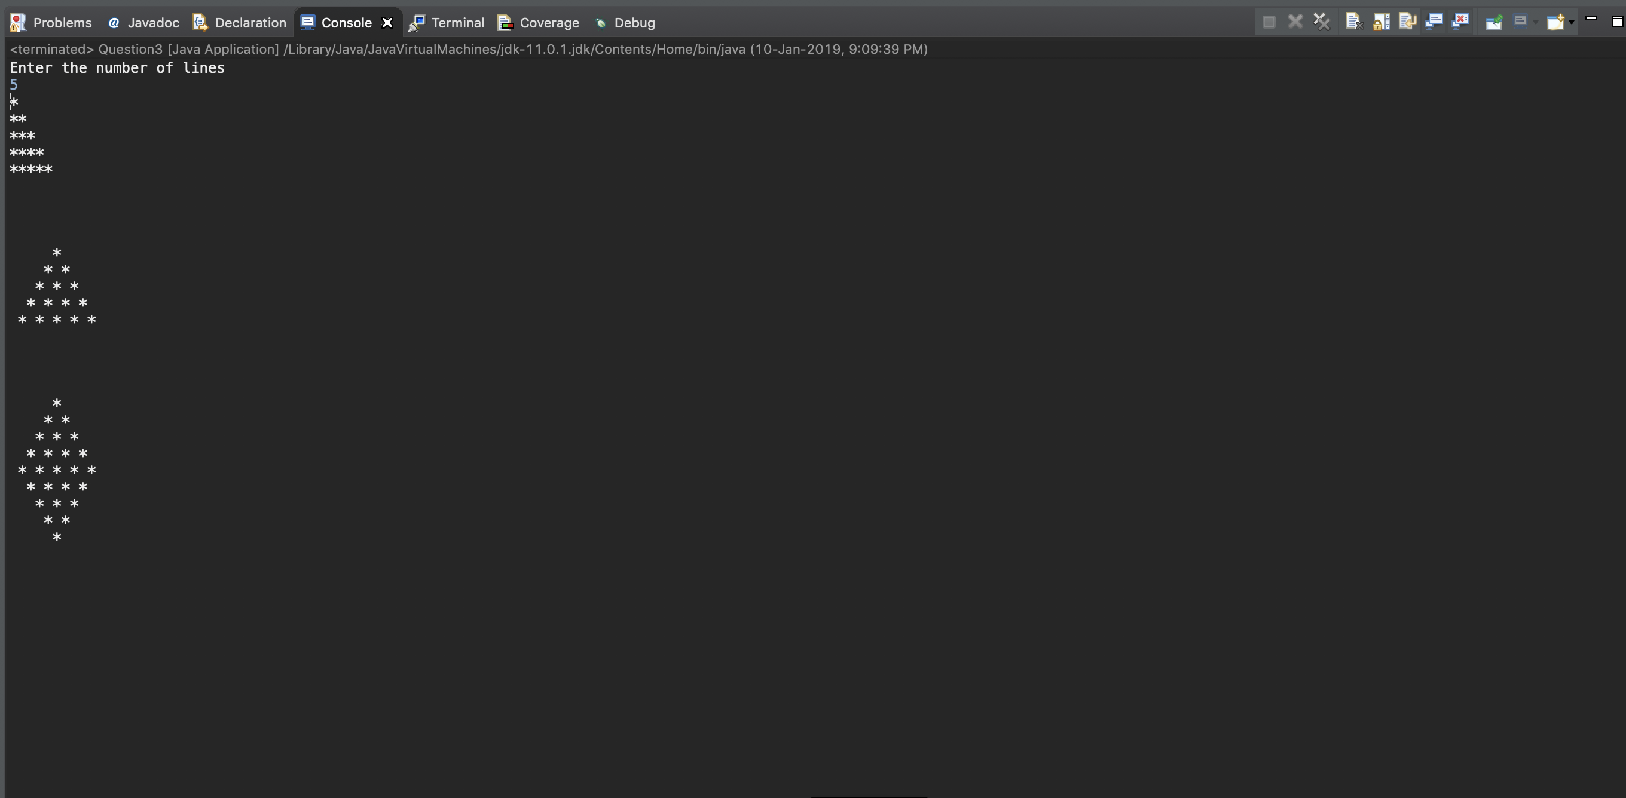

**Question 4**

Write a Java program to sum up all the digits of an integer till the sum is a single digit. Eg: INPUT = 9985

9+9+8+5 = 31

3+1 = 4 OUTPUT = 4

**Code**

import java.util.*;

public class Question4 {

public static void main(String args[])

{

Scanner sc = new Scanner(System.in);

int n;

System.out.println("Enter a number");

n = sc.nextInt();

//Finding the sum of digits till the number is a single digit

int num=n;

int digit, sum=num;

do

{

num = sum;

sum=0;

while(num>0)

{

digit = num%10;

sum+=digit;

num/=10;

}

}

while(sum>=10);

System.out.println("The Output is "+sum);

}

}

**Output**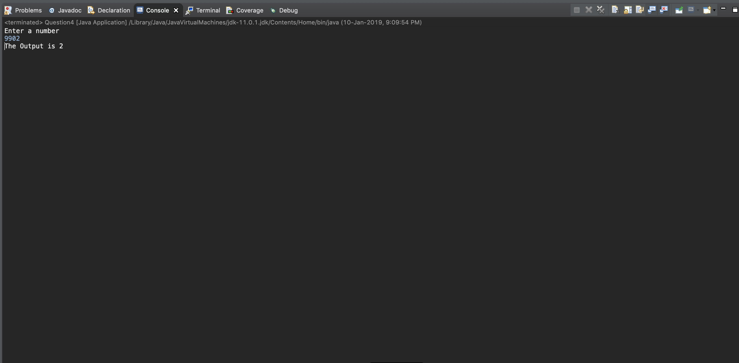

**Question 5**Write a Java program to sort a numerical array using selection sort algorithm and remove all the duplicates from the same array. [Hint: Use single array]

**Code**

import java.util.*;

public class Question5

{

public static void main(String args[])

{

//Selection sort

Scanner sc = new Scanner(System.in);

int len;

int i, j, temp;

System.out.println("Enter the size of the array");

len = sc.nextInt();

System.out.println("Enter the Elements of the array");

int a[] = new int[10];

for(i=0;i<len;i++)

{

a[i] = sc.nextInt();

}

//Selection sort algorithm

int minpos = 0;

for(i=0;i<len-1;i++)

{

minpos=i;

for(j=i+1;j<len;j++)

{

if(a[j]<a[minpos])

minpos = j;

}

//Swapping

temp = a[minpos];

a[minpos] = a[i];

a[i] = temp;

}

System.out.println("The sorted array is ");

for(i=0; i<len;i++)

{

System.out.print(a[i]+" ");

}

System.out.println();

}

}

**Output**

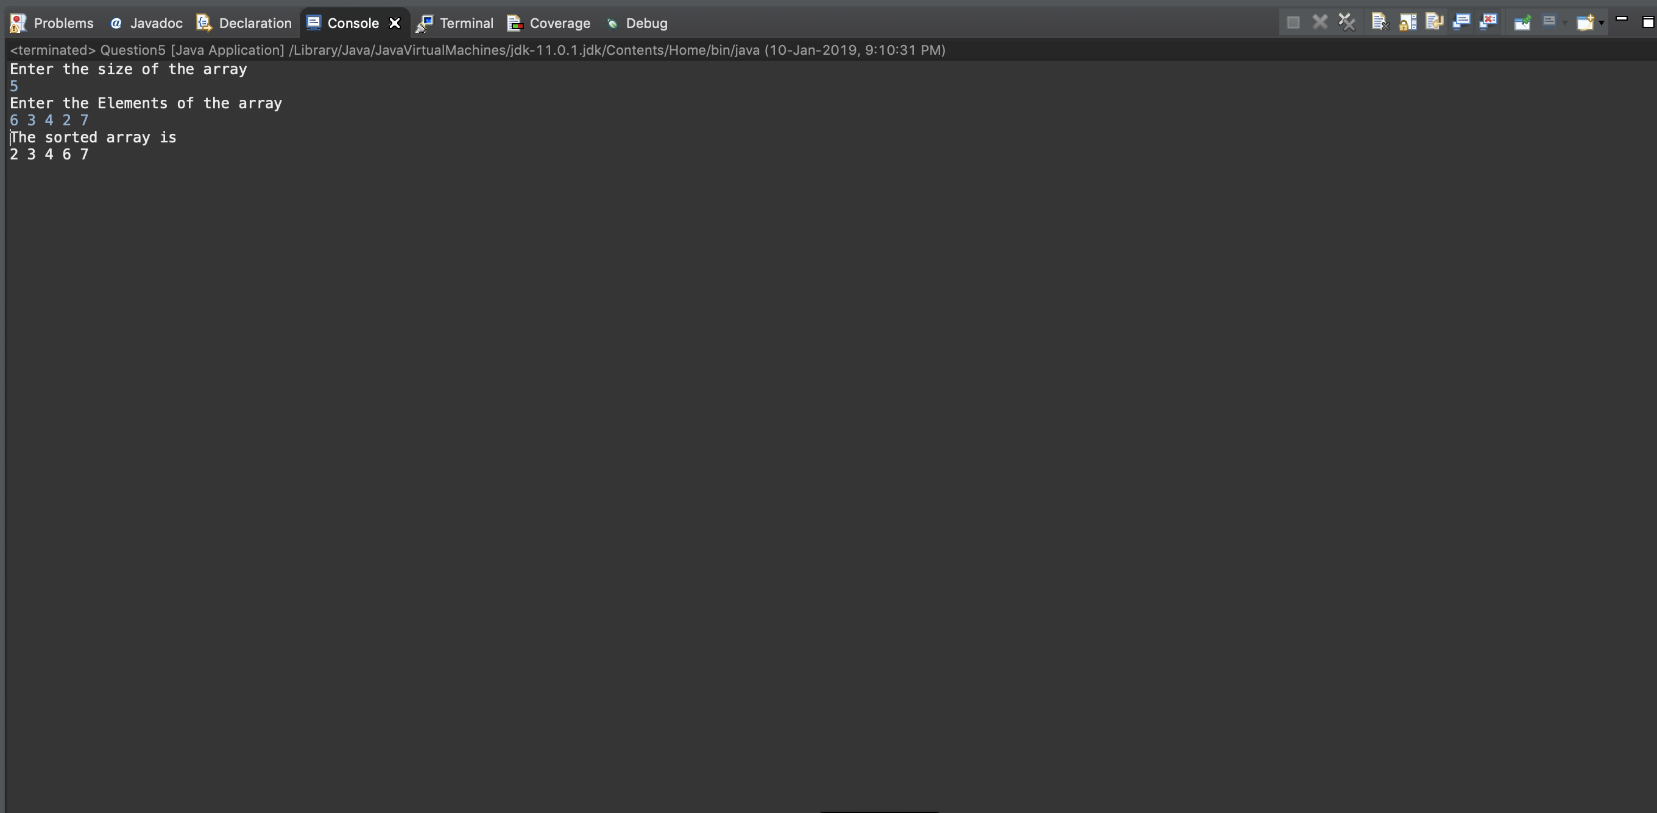

**Question 6**Write a Java program to read an integer ‘n’ from the user and display the multiplication table of ‘n’.

**Code**

import java.util.*;

public class Question6 {

public static void main(String args[])

{

Scanner sc = new Scanner(System.in);

int n;

System.out.println("Enter a number");

n = sc.nextInt();

System.out.println("Displaying the multiplication table of n");

for(int i=1;i<=12;i++)

{

System.out.println(n+" * "+i+" = "+(n*i));

}

}

}

**Output**

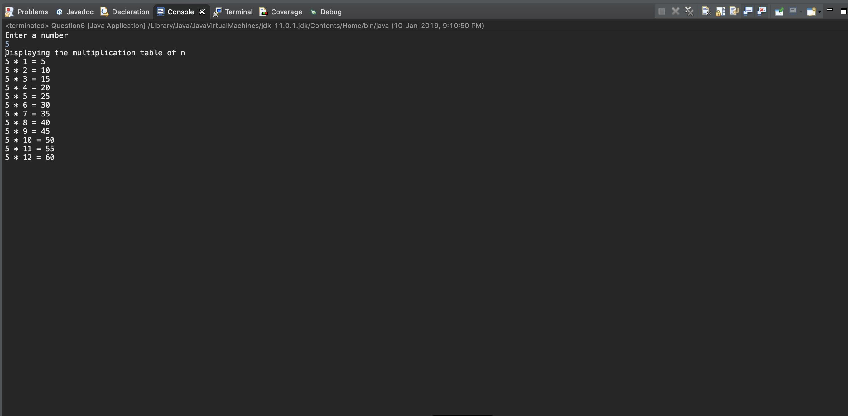

**Question 7**Write a Java program to list out the elements in an array having mid property. An element in an array is said to have the mid property if its left element is lesser than it and also the right element is greater than it.  
Eg: ..... , 3, 5, 9, ....

5 is having mid property.

**Code**

import java.util.*;

public class Question7

{

public static void main(String args[])

{

Scanner sc = new Scanner(System.in);

int len;

//System.out.println();

System.out.println("Enter the size of the array");

len = sc.nextInt();

int a[] = new int[len];

int i;

System.out.println("Enter the elements of the array");

for(i=0;i<len;i++)

{

a[i] = sc.nextInt();

}

for(i=1;i<len-1;i++)

{

if(a[i-1]<a[i] && a[i+1]>a[i])

{

System.out.println(a[i]+" in position "+(i+1)+" has mid property");

}

}

}

}

**Output**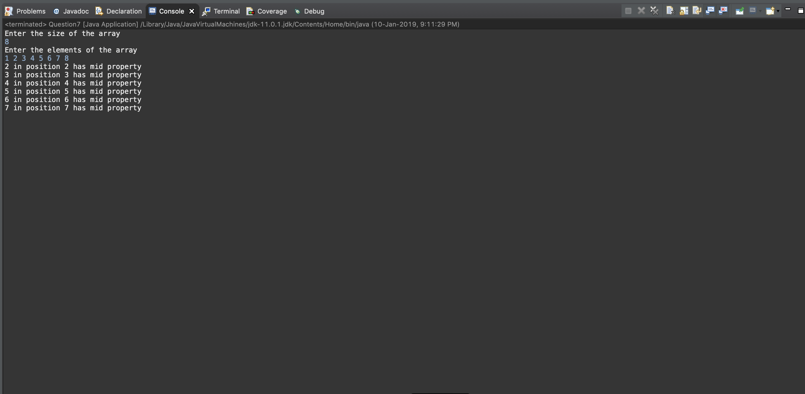

**Question 8**

Print Hailstone sequence for a number.

(Note: Take any positive integer n. If n is even, divide it by 2 to get n / 2. If n is odd, multiply it by 3 and add 1 to obtain 3n + 1. Repeat the process indefinitely. The conjecture is that no matter what number you start with, you will always eventually reach 1.)

Eg. Hailstone sequence of 15 is

15, 46, 23, 70, 35, 106, 53, 160, 80, 40, 20, 10, 5, 16, 8, 4, 2, 1

**Code**

import java.util.*;

public class Question8

{

public static void main(String args[])

{

Scanner sc = new Scanner(System.in);

int n;

System.out.println("Enter a number");

n = sc.nextInt();

//Printing the hailstone sequence

int num = n;

while(num!=1)

{

if(num%2 == 0)

{

num/=2;

}

else

{

num = 3*num +1;

}

System.out.print(num+" ");

}

}

}

**Output**

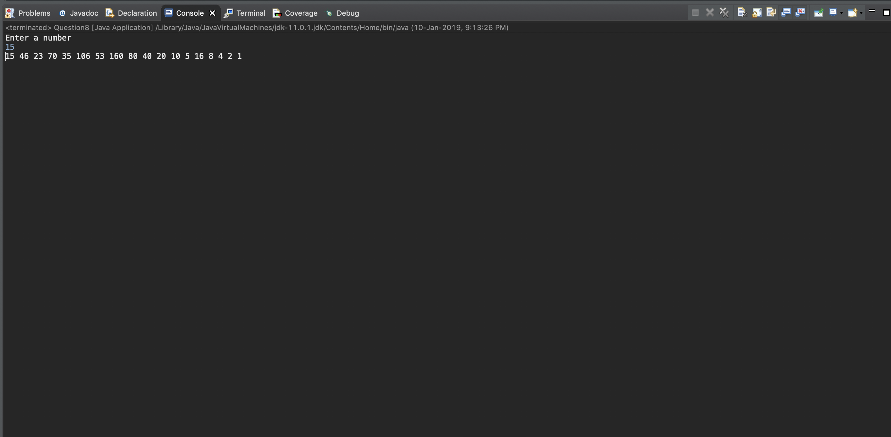

**Question 9**

Find whether an entered number is CIRCULAR PRIME or not. Display YES if it is a circular prime, otherwise display NO. A circular prime number is a number that remains prime on any cyclic rotation of its digits (in base 10).  
For example 1193 is circular prime because 1931, 9311, 3119 and 1193 are all prime numbers.

**Code**

import java.util.*;

public class Question9

{

static boolean isprime(int num)

{

int i, c=0;

for(i=2;i<num/2;i++)

{

if(num%i==0)

{

c+=1;

break;

}

}

if(c==0)

return true;

else

return false;

}

static String permute(String s)

{

return s.substring(1)+ s.substring(0,1);

}

public static void main(String args[])

{

Scanner sc = new Scanner(System.in);

int n;

System.out.println("Enter a number");

n = sc.nextInt();

//Step 1: Permuting the numbers

int i, num, c=0;

String s = Integer.toString(n);

for(i=0;i<s.length();i++)

{

num = Integer.parseInt(s);

if(!isprime(num))

{

c+=1;

break;

}

//Permute

s = permute(s);

}

if(c==0)

System.out.println("The number is Circular Prime");

else

System.out.println("The number is not Circular Prime");

}

}

**Output**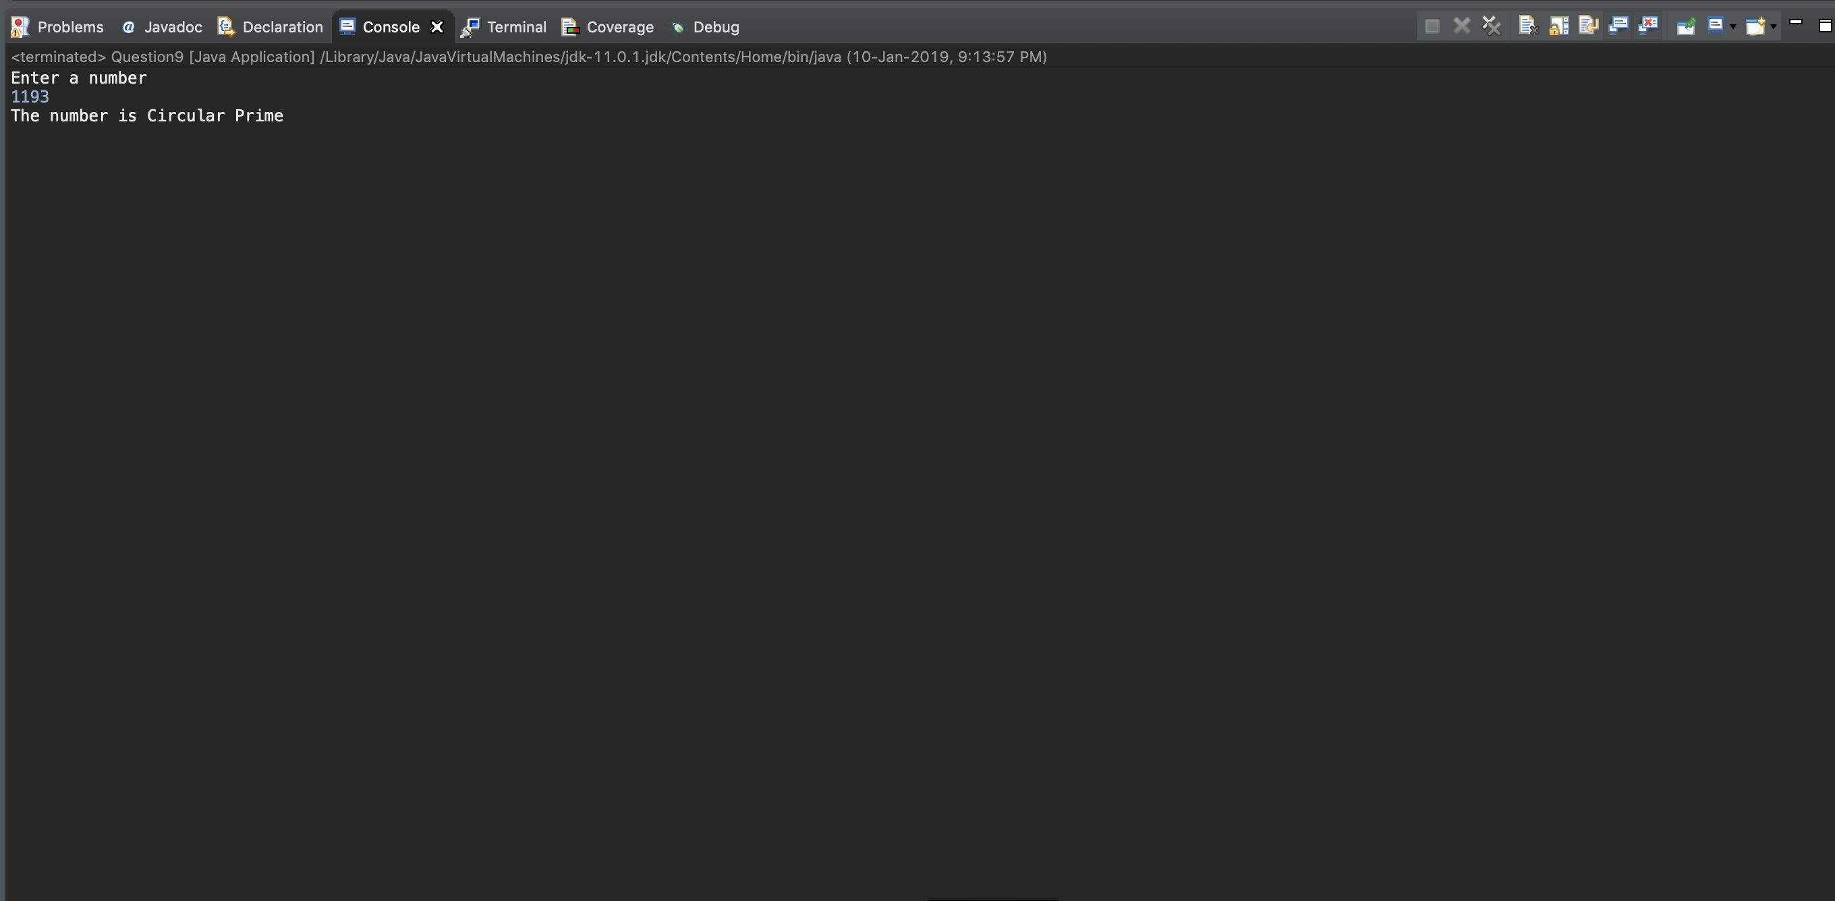

**Question 10**

Write a Java program to find out the greatest common divisor of two input values using a function.

**Code**

import java.util.*;

public class Question10

{

//Function to return the GCD of two numbers

static int gcd(int a, int b)

{

int rem=1;

while(rem!=0)

{

rem = b%a;

b=a;

a=rem;

}

return b;

}

public static void main(String args[])

{

Scanner sc = new Scanner(System.in);

int a, b;

System.out.println("Enter two numbers");

a = sc.nextInt();

b = sc.nextInt();

System.out.println("The GCD of "+a+" and "+b+" is "+ gcd(a,b));

}

}

**Output**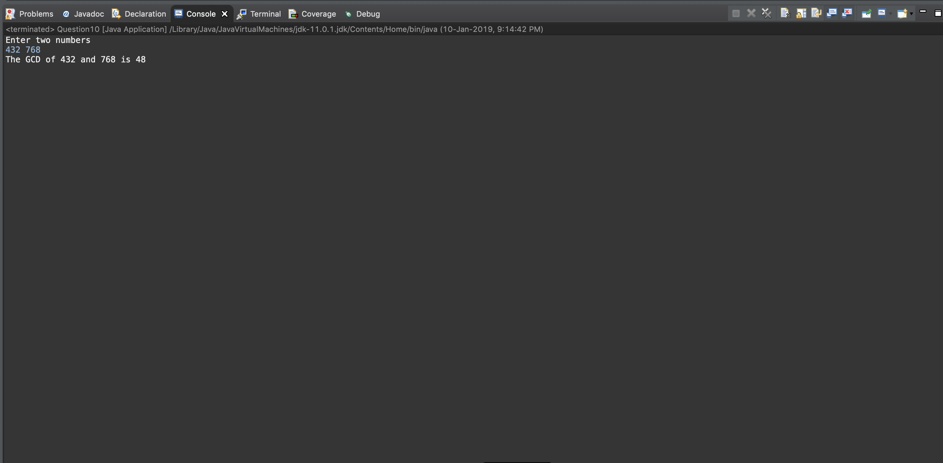

**Question 11**

Write a Java program to reverse the contents of the array using different functions for different types of array (without using any secondary array for reversing).

**Code**

import java.util.*;

public class Question11

{

static int[] revint(int a[])

{

int len = a.length;

int end = len-1, temp;

for(int i=0;i<len/2;i++)

{

temp = a[i];

a[i]=a[end];

a[end]=temp;

end-=1;

}

return a;

}

static char[] revchar(char a[])

{

int len = a.length;

int end = len-1;

char temp;

for(int i=0;i<len/2;i++)

{

temp = a[i];

a[i]=a[end];

a[end]=temp;

end-=1;

}

return a;

}

static String[] revstring(String a[])

{

int len = a.length;

int end = len-1;

String temp;

for(int i=0;i<len/2;i++)

{

temp = a[i];

a[i]=a[end];

a[end]=temp;

end-=1;

}

return a;

}

static double[] revdouble(double a[])

{

int len = a.length;

int end = len-1;

double temp;

for(int i=0;i<len/2;i++)

{

temp = a[i];

a[i]=a[end];

a[end]=temp;

end-=1;

}

return a;

}

public static void main(String args[])

{

Scanner sc = new Scanner(System.in);

System.out.println("Enter the type of the array:\nEnter 1 for Integer \nEnter 2 for Character \nEnter 3 for String \nEnter 4 for Double");

int ch=sc.nextInt();

System.out.println("Enter the size of the array");

int len = sc.nextInt();

int i;

System.out.println("Enter the elements of the array");

switch(ch)

{

case 1:

int a[] = new int[len];

for(i=0;i<len;i++)

a[i] = sc.nextInt();

System.out.println("Printing the array in reverse order: ");

a = revint(a);

for(i=0;i<len;i++)

System.out.print(a[i]+" ");

break;

case 2:

char b[] = new char[len];

for(i=0;i<len;i++)

b[i] = sc.next().charAt(0);

System.out.println("Printing the array in reverse order: ");

b = revchar(b);

for(i=0;i<len;i++)

System.out.print(b[i]+" ");

break;

case 3:

sc.nextLine();

String c[] = new String[len];

for(i=0;i<len;i++)

c[i] = sc.nextLine();

for(i=0;i<len;i++)

System.out.print(c[i]+" ");

System.out.println();

System.out.println("Printing the array in reverse order: ");

c = revstring(c);

for(i=0;i<len;i++)

System.out.print(c[i]+" ");

break;

case 4:

double d[] = new double[len];

for(i=0;i<len;i++)

d[i] = sc.nextDouble();

System.out.println("Printing the array in reverse order: ");

d = revdouble(d);

for(i=0;i<len;i++)

System.out.print(d[i]+" ");

break;

}

}

}

**Output**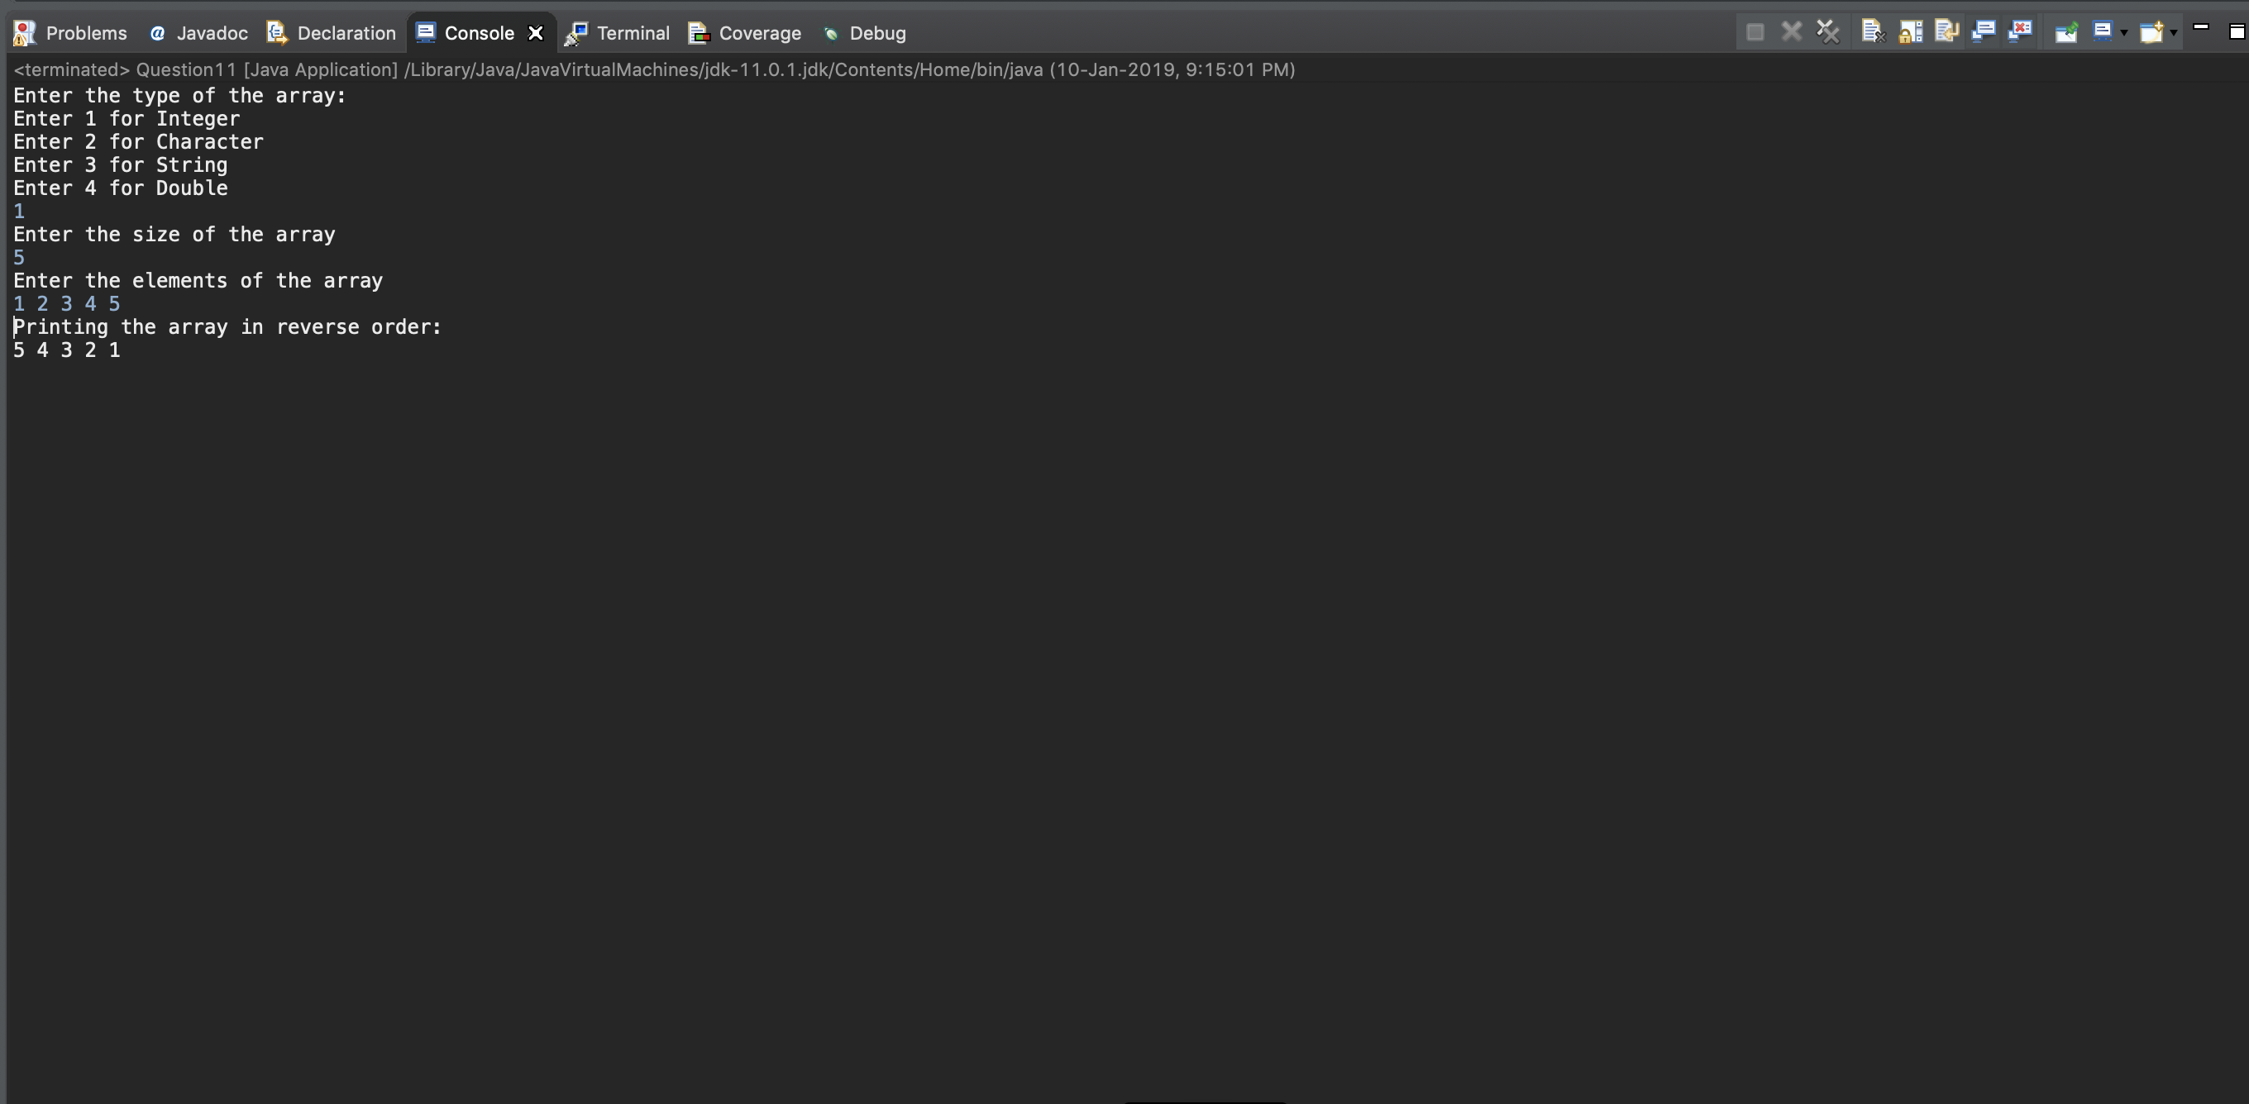

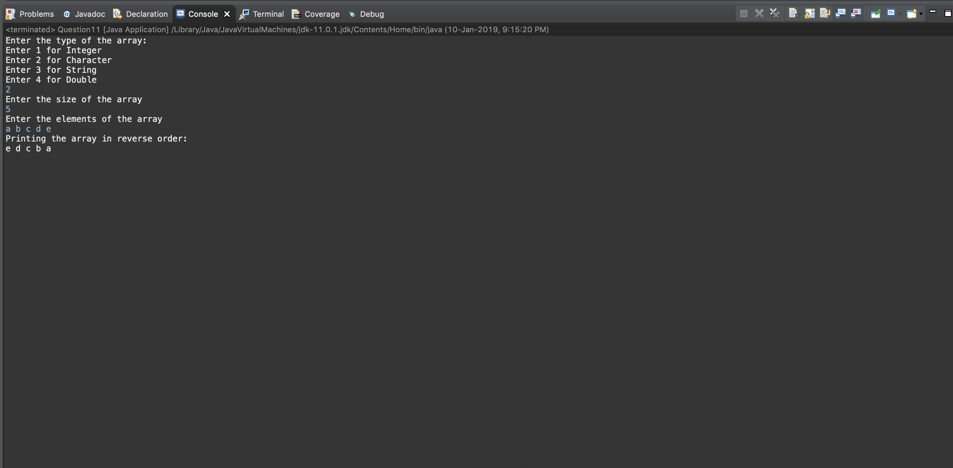

**Question 12**

Write a Java program to check the given string is palindrome or not.

**Code**

import java.util.*;

public class Question12

{

public static void main(String args[])

{

Scanner sc = new Scanner(System.in);

System.out.println("Enter a string");

String s= sc.nextLine();

String s2="";

//Reverse the string

for(int i=0;i<s.length();i++)

{

s2=s.charAt(i)+s2;

}

if(s.compareTo(s2)==0)

System.out.println("The String is a palindrome");

else

System.out.println("The String is not a palindrome");

}

}

**Output**

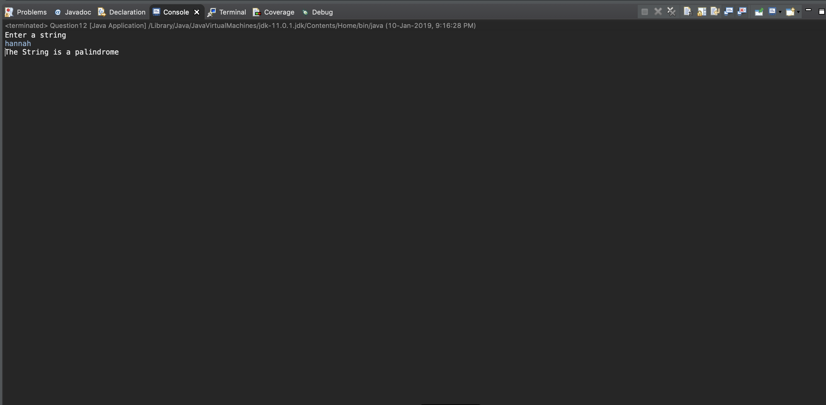

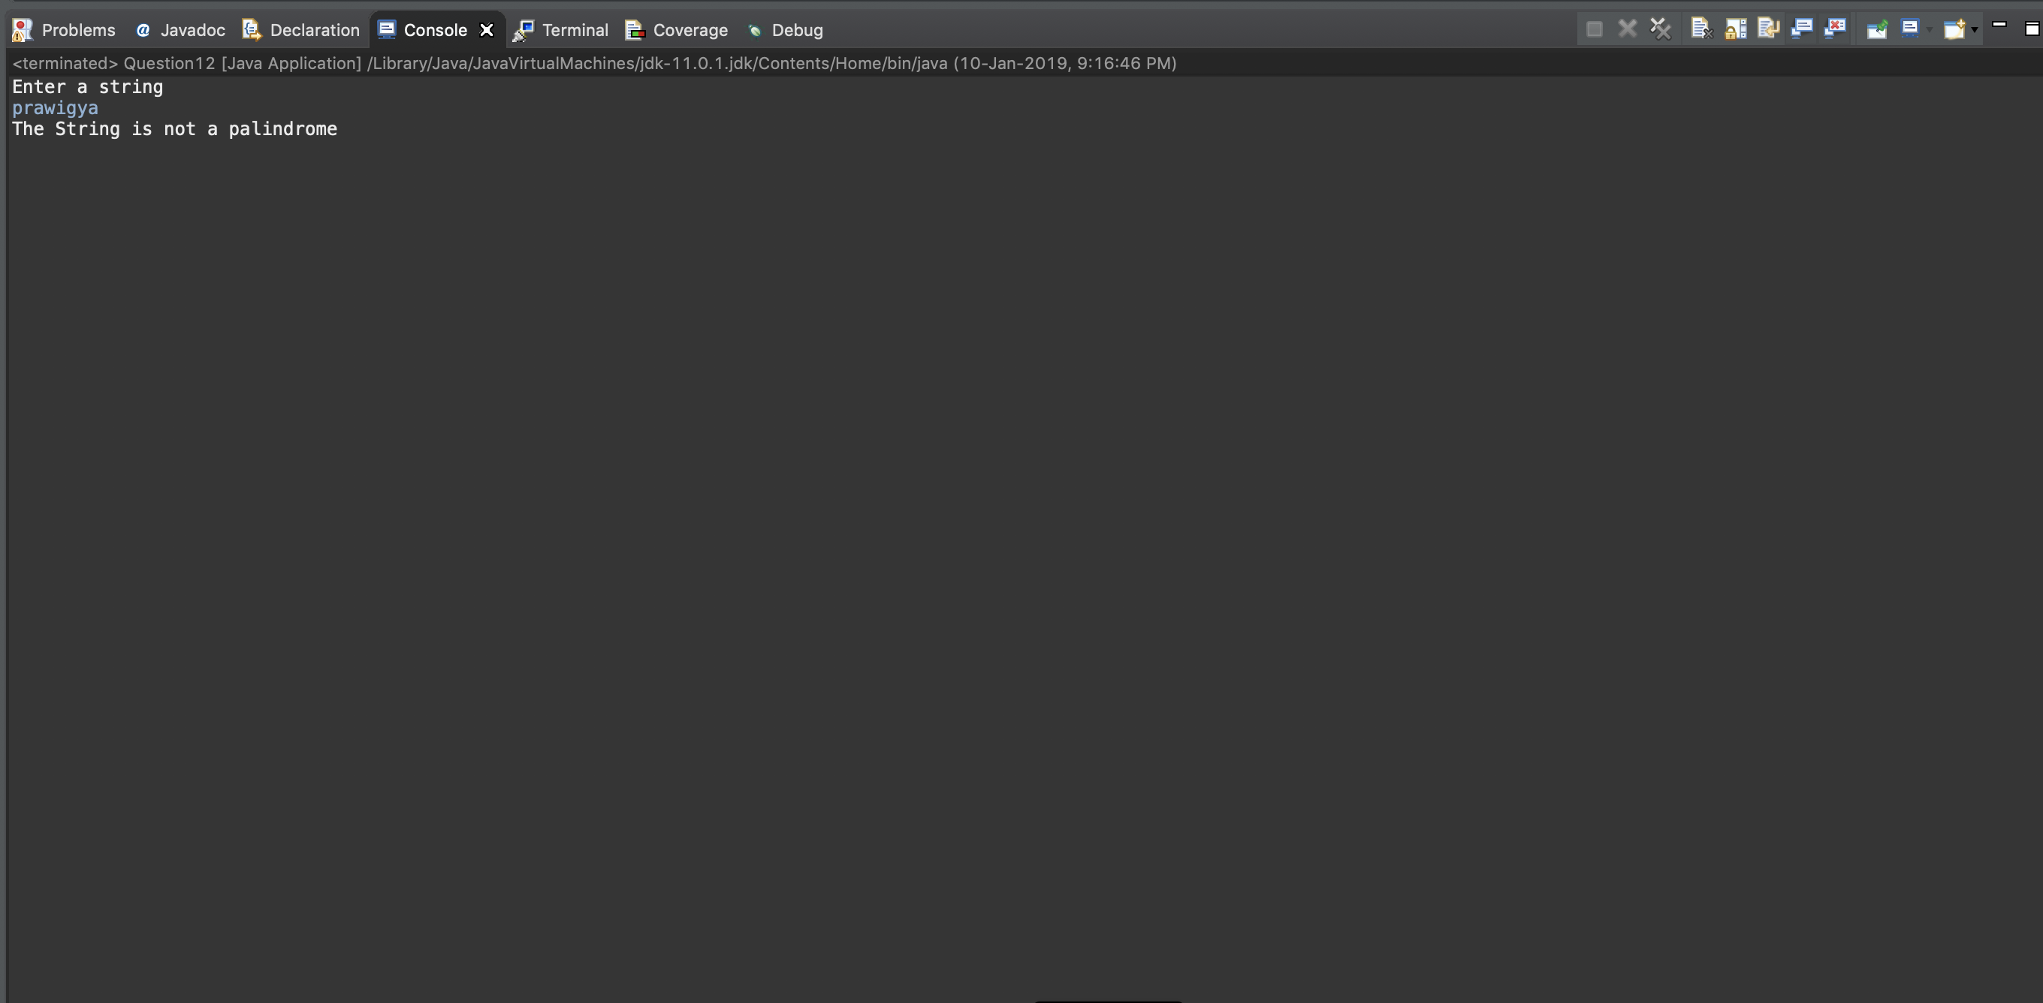

**Question 13**

Write a Java program to insert a string into another string and delete a substring from a string.

**Code**

import java.util.*;

public class Question13

{

public static void main(String args[])

{

Scanner sc = new Scanner(System.in);

System.out.println("Enter a String");

String s = sc.nextLine();

System.out.println("Enter the substring you want to insert into the String");

String s1 = sc.nextLine();

System.out.println("Enter the position that you want to enter the String into");

int pos = sc.nextInt();

//Enter the substring into the string

String sub1="", sub2="";

sub1 = s.substring(0,pos);

sub2=s.substring(pos);

s = sub1 + s1 + sub2;

System.out.println("New String \n"+s);

//Part 2

sc.nextLine();

System.out.println("Enter a substring to delete from the string");

String s2= sc.nextLine();

int pos2 = s.indexOf(s2);

s = s.substring(0,pos2) + s.substring(pos2+s2.length());

System.out.println("New String \n"+s);

}

}

**Output**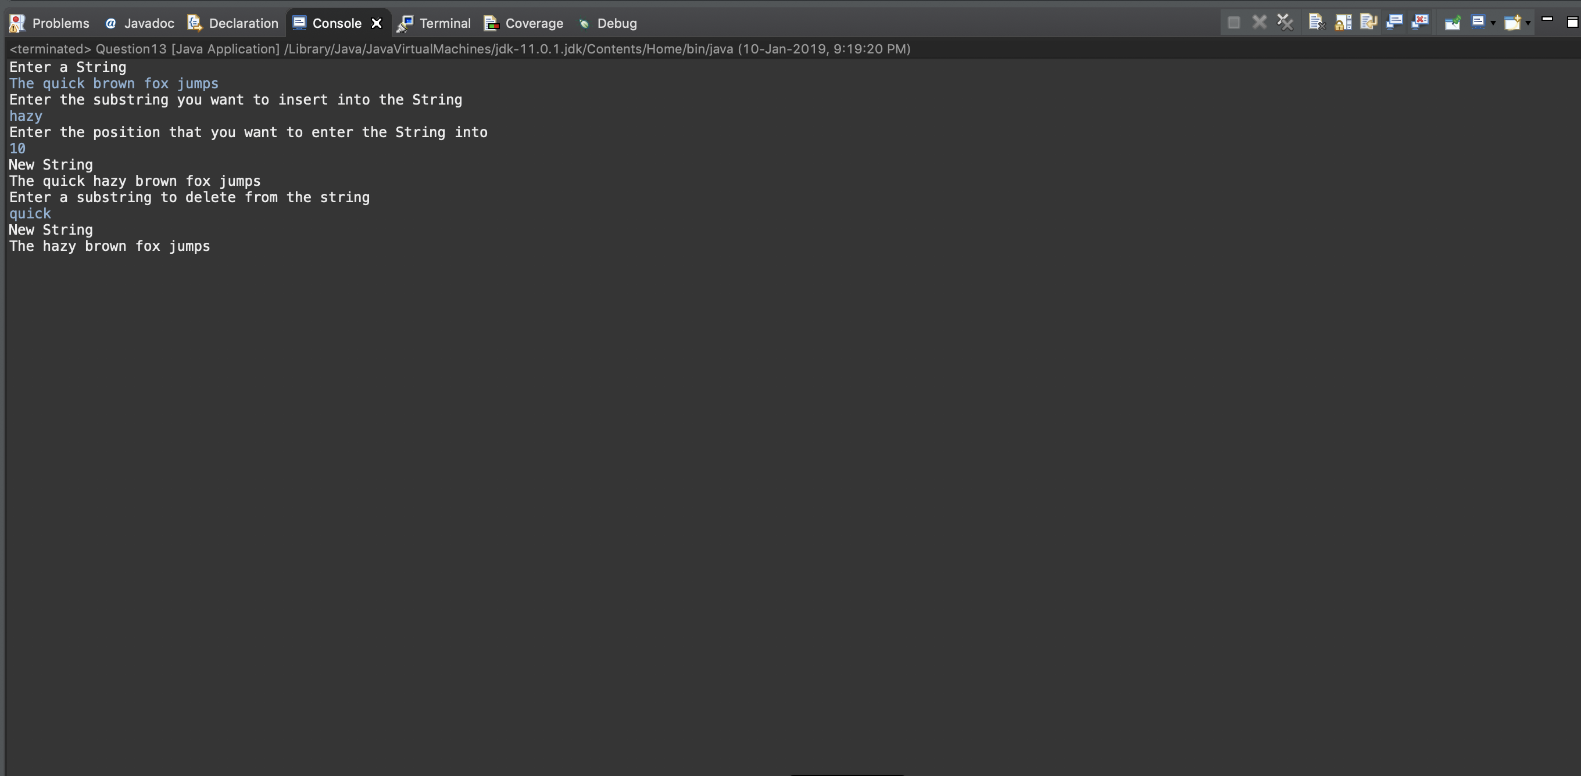

**Question 14**

Write a Java program to find out the number of occurrences of a pattern string in a given text.

**Code**

import java.util.*;

public class Question14

{

public static void main(String args[])

{

Scanner sc = new Scanner(System.in);

System.out.println("Enter a text");

String s = sc.nextLine();

//sc.nextLine();

System.out.println("Enter a pattern ");

String p = sc.nextLine();

int c=0,pos=0;

while(true)

{

pos = s.indexOf(p,pos);

if(pos==-1)

break;

c+=1;

pos+=1;

}

System.out.println("The number of occurences of "+p+" in the text is "+c);

}

}

**Output**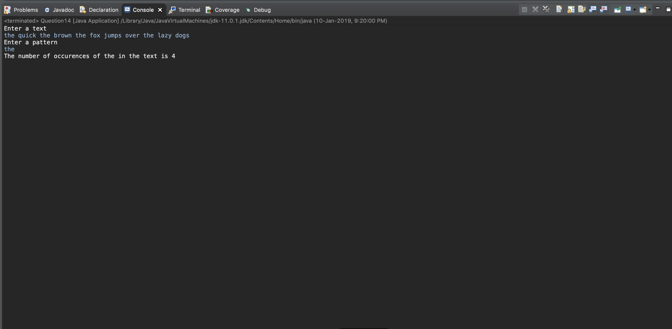

**Question 15**Write a Java program to swap two values in a SWAP( ) method using wrapper classes.

**Code**

import java.util.*;

public class Question15 {

int a;

Question15()

{

a=0;

}

//swap 2 values in a method using wrapper class

static void swap(Question15 ob1, Question15 ob2)

{

int temp = ob1.a;

ob1.a = ob2.a;

ob2.a = temp;

}

public static void main(String args[])

{

Scanner sc = new Scanner(System.in);

System.out.println("Enter a number");

Question15 ob1 = new Question15();

ob1.a = sc.nextInt();

System.out.println("Enter a number");

Question15 ob2 = new Question15();

ob2.a = sc.nextInt();

swap(ob1, ob2);

System.out.println("The numbers after swapping");

System.out.println(ob1.a+" "+ob2.a);

}

}

**Output**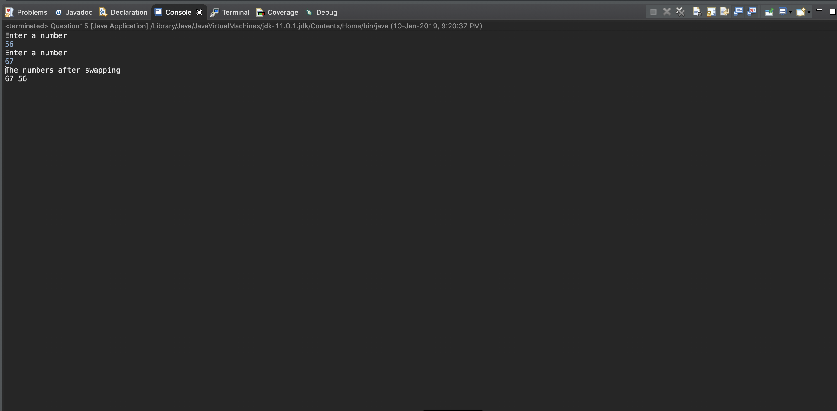

**Question 16**

Write a Java program to convert the decimal number to binary, octal, and hexadecimal   
numbers using wrapper class methods. [Hint: Integer and Long classes]

**Code**

import java.util.*;

public class Question16a

{

int dec, oct, hex;

long bin;

Question16a()

{

dec=0;

oct=0;

hex=0;

bin=0;

}

static long decToBinary(int d)

{

long b = Long.parseLong(Integer.toBinaryString(d));

return b;

}

static int decToOct(int d)

{

int a = Integer.parseInt(Integer.toOctalString(d));

return a;

}

static int decToHex(int d)

{

int a = Integer.parseInt(Integer.toHexString(d));

return a;

}

public static void main(String args[])

{

Scanner sc = new Scanner(System.in);

System.out.println("Enter a decimal number");

Question16a ob = new Question16a();

ob.dec = sc.nextInt();

ob.oct = decToOct(ob.dec);

ob.hex = decToHex(ob.dec);

ob.bin = decToBinary(ob.dec);

System.out.println("The Binary equivalent is "+ob.bin);

System.out.println("The Octal equivalent is "+ob.oct);

System.out.println("The Hexa-Decimal equivalent is "+ob.hex);

}

}

**Output**

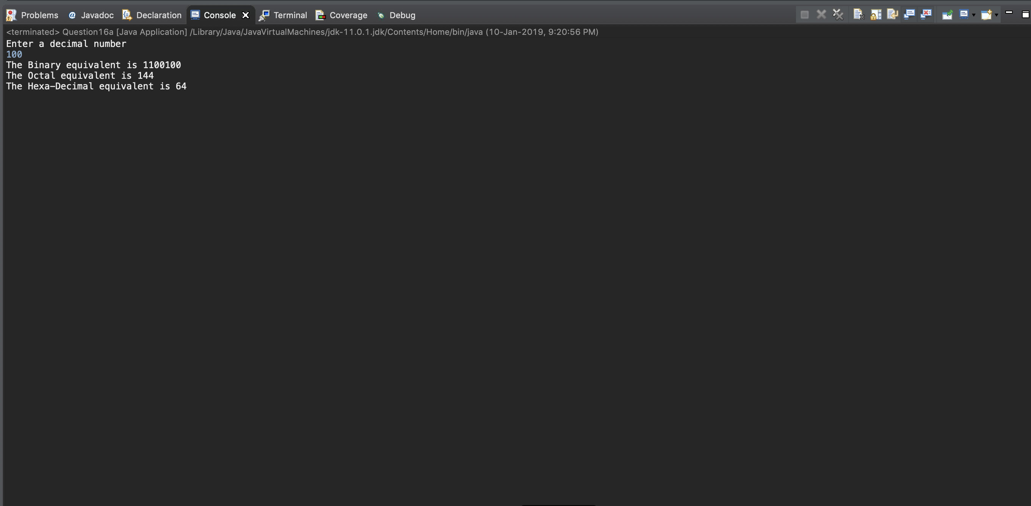

**Question 17**

Write a class definition for ‘stu’ with name, regno, and cgpa values and required methods as members of the class. Create an array of objects of ‘stu’ for ‘n’ number of students in G2 slot. Write a Java program to display the name and registration numbers   
of the students who have CGPA less than 4 in G2 slot.

**Code**

import java.util.*;

public class Question17

{

String name, regno;

double cgpa;

Question17()

{

name = "";

regno="";

cgpa = 0.0;

}

void init(Question17 ob)

{

Scanner sc = new Scanner(System.in);

System.out.println("Enter the name of the Student");

ob.name= sc.nextLine();

System.out.println("Enter the Registration number of "+ob.name);

ob.regno = sc.nextLine();

System.out.println("Enter the CGPA of "+ob.name);

ob.cgpa = sc.nextDouble();

}

public static void main(String args[])

{

int n;

Scanner sc = new Scanner(System.in);

System.out.println("Enter the number of Students");

n = sc.nextInt();

Question17[] StudentArray = new Question17[n];

int i;

for(i = 0;i<n;i++)

{

StudentArray[i] = new Question17();

StudentArray[i].init(StudentArray[i]);

}

System.out.println("Students with CGPA more than 4");

for(i = 0;i<n;i++)

{

if(StudentArray[i].cgpa>4)

System.out.println(StudentArray[i].name+" "+StudentArray[i].regno);

}

}

}

**Output**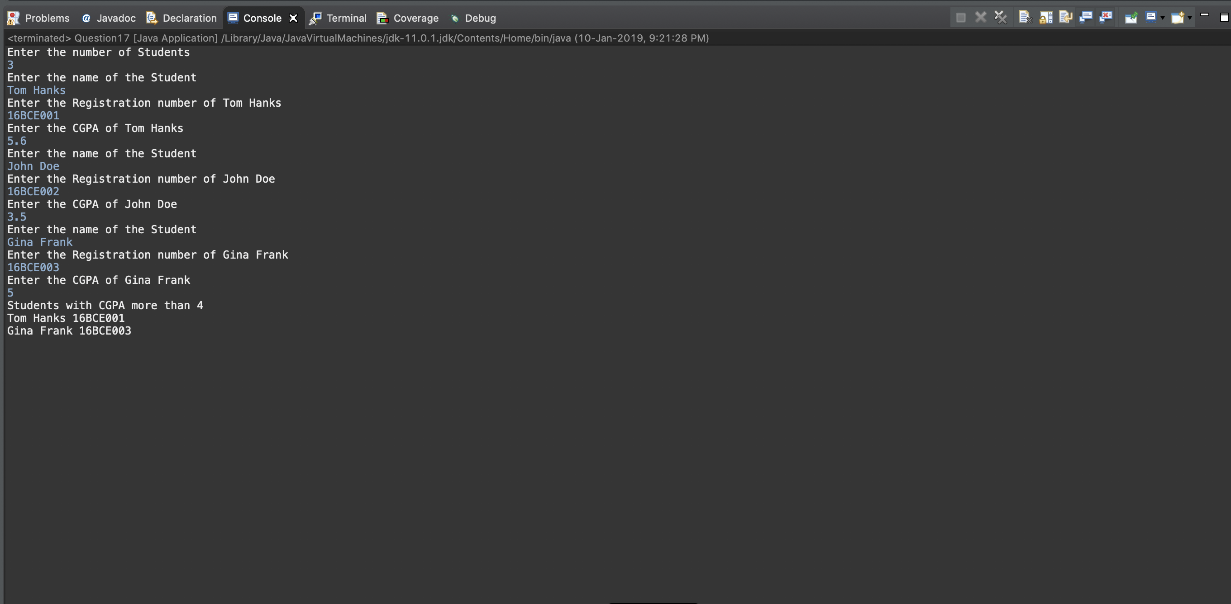

**Question 18**

Write a Java program to implement complex number arithmetic using classes and use   
multiple constructors for initialising the complex numbers.

**Code**

import java.util.*;

public class Question18

{

int real;

int imag;

Question18()

{

real = 0;

imag = 0;

}

Question18(int real, int imag)

{

this.real = real;

this.imag = imag;

}

public static void main(String args[])

{

Scanner sc = new Scanner(System.in);

Question18 ob1 = new Question18();

Question18 ob2 = new Question18();

int r, i;

System.out.println("Enter the real part of first complex number");

r = sc.nextInt();

System.out.println("Enter the imaginary part of first complex number");

i = sc.nextInt();

ob1 = new Question18(r,i);

System.out.println("The first complex number is "+ob1.real+"+("+ob1.imag+"i)");

System.out.println("Enter the real part of second complex number");

r = sc.nextInt();

System.out.println("Enter the imaginary part of second complex number");

i = sc.nextInt();

ob2 = new Question18(r,i);

System.out.println("The second complex number is "+ob2.real+"+("+ob2.imag+"i)");

int tempr, tempi;

//Adding the two numbers

tempr = ob1.real + ob2.real;

tempi = ob1.imag + ob2.imag;

System.out.println("Sum of two numbers = "+tempr+"+("+tempi+"i)");

//Subtracting the two numbers

tempr = ob1.real - ob2.real;

tempi = ob1.imag - ob2.imag;

System.out.println("Difference of two numbers = "+tempr+"+("+tempi+"i)");

//Multiplying the two numbers

tempr = ob1.real*ob2.real - ob1.imag*ob2.imag;

tempi = ob1.imag*ob2.real + ob1.real*ob2.imag;

System.out.println("Product of two numbers = "+tempr+"+("+tempi+"i)");

}

}

**Output**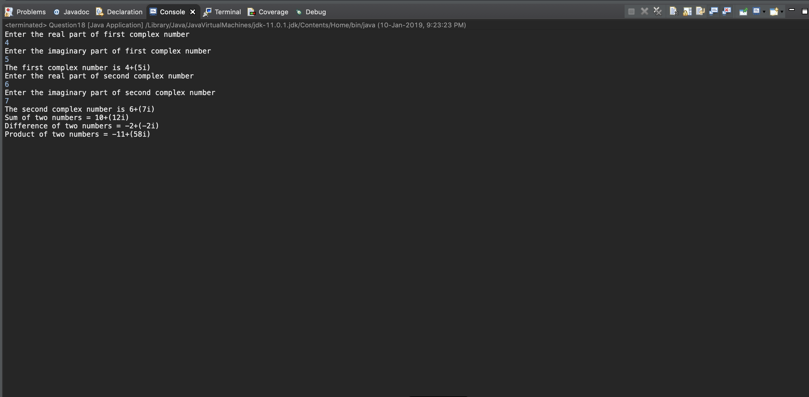

**Question 19**

Write a Java program to print a pattern using a method PRINT( ) as follows:   
*  
**  
***  
****  
*****  
The type of the character and/or the number of lines to be printed can be taken as input from the user. The default values are ‘*’ and 5. Using the concept of method overloading write different definitions for PRINT( ) with different argument list.

**Code**

import java.util.*;

public class Question19 {

static void PRINT(char p, int n)

{

int i,j;

for(i=1;i<=n;i++)

{

for(j=1;j<=i;j++)

System.out.print(p);

System.out.println();

}

}

static void PRINT(char p)

{

int i, j;

for(i=1;i<=5;i++)

{

for(j=1;j<=i;j++)

System.out.print(p);

System.out.println();

}

}

static void PRINT(int n)

{

int i, j;

for(i=1;i<=n;i++)

{

for(j=1;j<=i;j++)

System.out.print('*');

System.out.println();

}

}

static void PRINT()

{

int i, j;

for(i=1;i<=5;i++)

{

for(j=1;j<=i;j++)

System.out.print('*');

System.out.println();

}

}

public static void main(String args[])

{

Scanner sc = new Scanner(System.in);

int n=0, ch;

boolean nc=false,np=false;

char p='-';

System.out.println("Do you want to enter value of n? 1/0");

ch=sc.nextInt();

if(ch==1)

{

System.out.println("Enter the value of n");

n=sc.nextInt();

nc=true;

}

System.out.println("Do you want to enter value of p? 1/0");

ch=sc.nextInt();

if(ch==1)

{

System.out.println("Enter the value of p");

p=sc.next().charAt(0);

np=true;

}

if(nc && np)

PRINT(p,n);

else if(nc && !np)

PRINT(n);

else if(!nc && np)

PRINT(p);

else

PRINT();

}

}

**Output**

